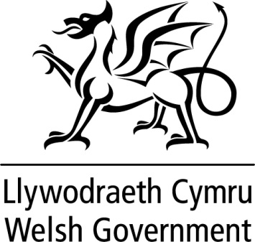

ORAL QUESTION
TABLED ON 18 MAY 2023
FOR ANSWER BY THE FIRST MINISTER

ON 23 MAY 2023

12. Janet Finch-Saunders (Aberconwy) What steps is the Welsh Government is taking to improve road safety on the A470 in Aberconwy? (OQ59561)

First Minister: Welsh Government officials are putting a business case to the National Transport Delivery Plan Board to include a new WelTAG study between Glan Conwy and Betws y Coed. If included, it will need to be prioritised alongside similar studies across Wales.

